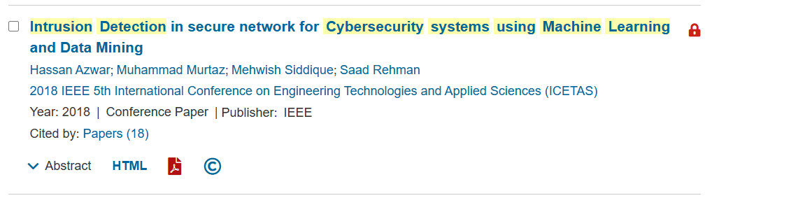Date of Conference: 22-23 November 2018
Date Added to IEEE Xplore: 31 January 2019
ISBN Information:
DOI: 10.1109/ICETAS.2018.8629197
Publisher: IEEE
Conference Location: Bangkok, Thailand
